Node-Red: Sending an Image to Your Cellphone

This “recipe” will use the Pushbullet webservice to send message to our cellphone.

Part 1: Registering for Pushbullet and Obtaining an API Access Key

1. Browse to [www.pushbullet.com](http://www.pushbullet.com)

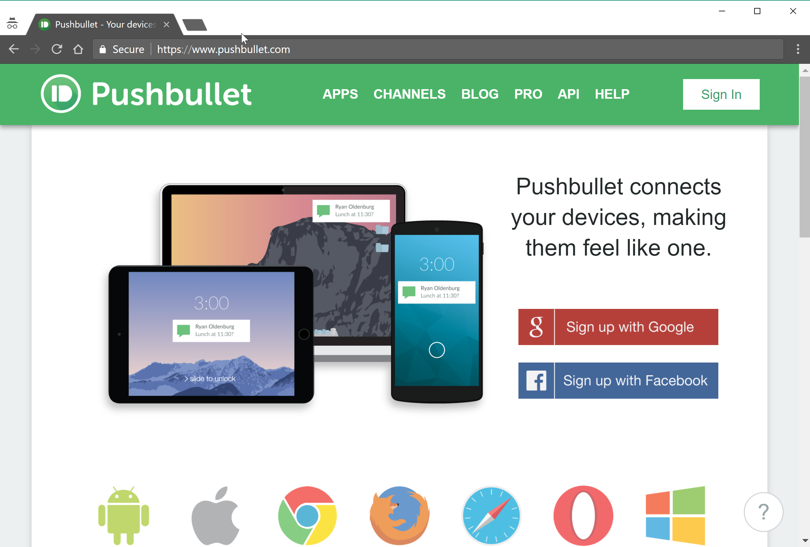

1. Register for a new account or sign into an existing account.
2. Once registered, obtain a new Access Token so we can work with the Pushbullet API:
   1. Click on your profile picture
   2. Click **My Account**

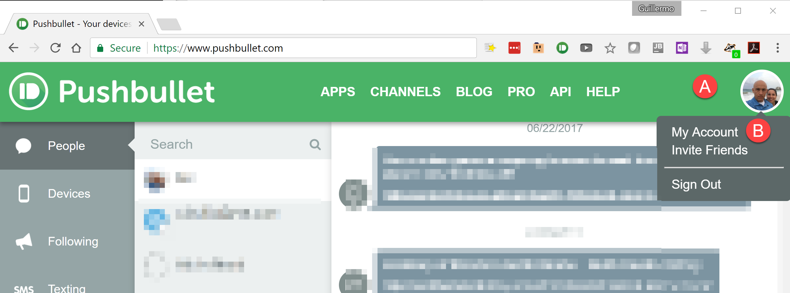

1. Scroll down and click **Create Access Token** beneath *Access Tokens*

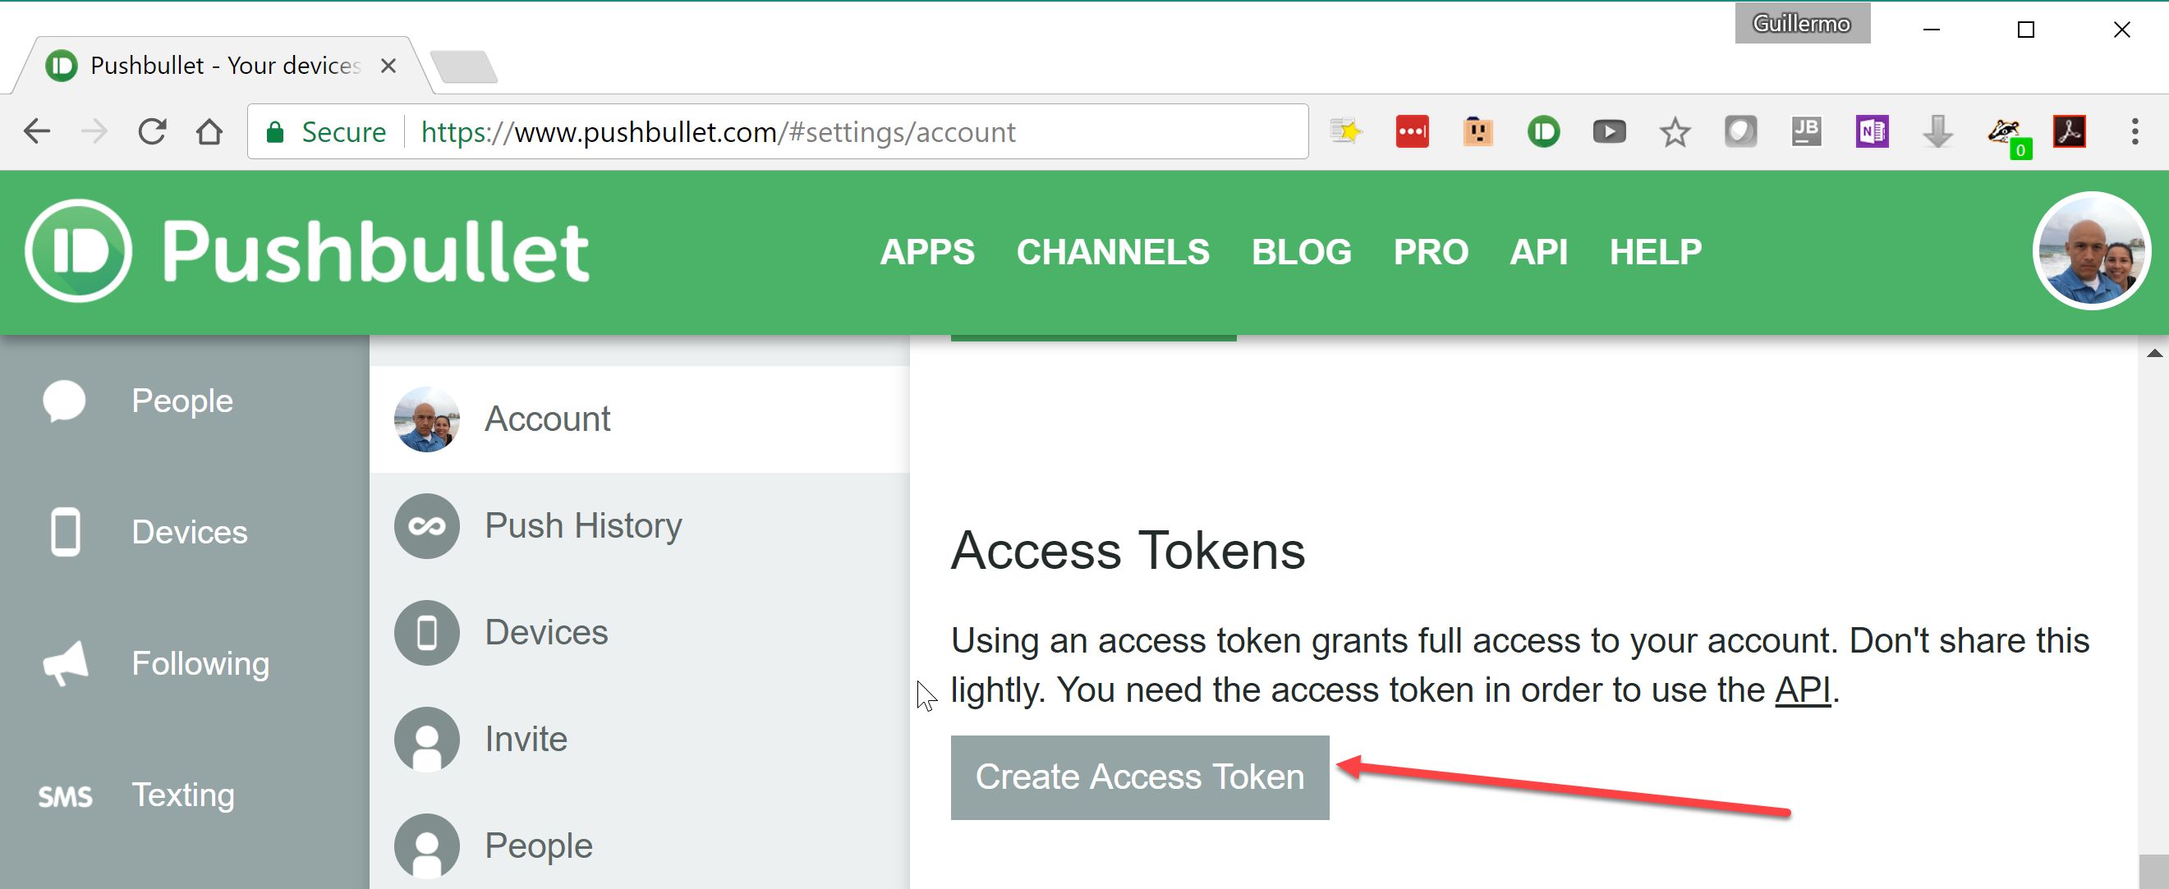

1. This will create a new access token, which will we will use later (note: only part of the token is shown in the screenshot below).

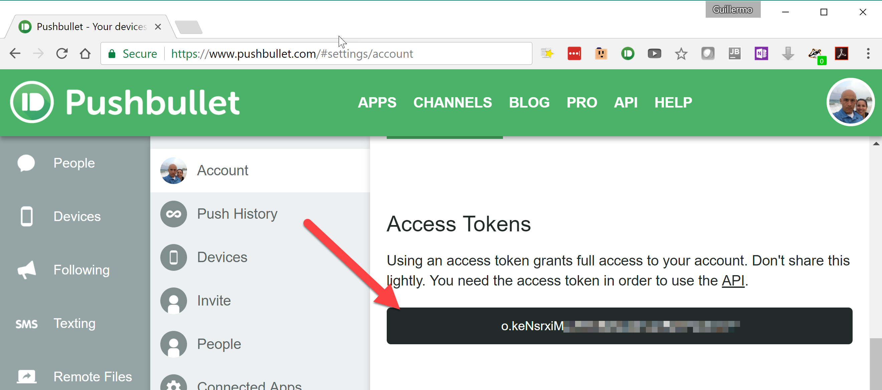

1. Leave the window or tab displaying your Pushbullet access token open. Open another window or tab and display Node-Red.

Part 2: Install Pushbullet on Your Mobile Device

Part 3: Adding the Pushbullet Node to The Node Red Palette

1. To use Pushbullet with Node Red, we will have to add a new node to our Node Red palette.
   1. In Node Red, click on the “more” or “hamburger” menu.
   2. Click **Manage palette**

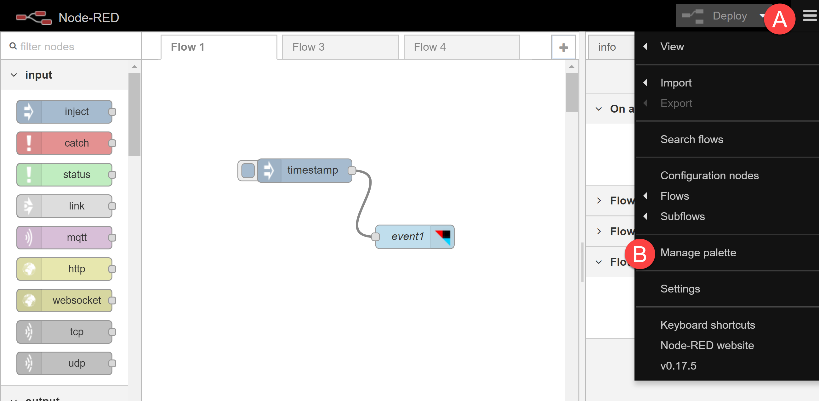

1. When the *User Settings* screen appears, click the **Install** tab.

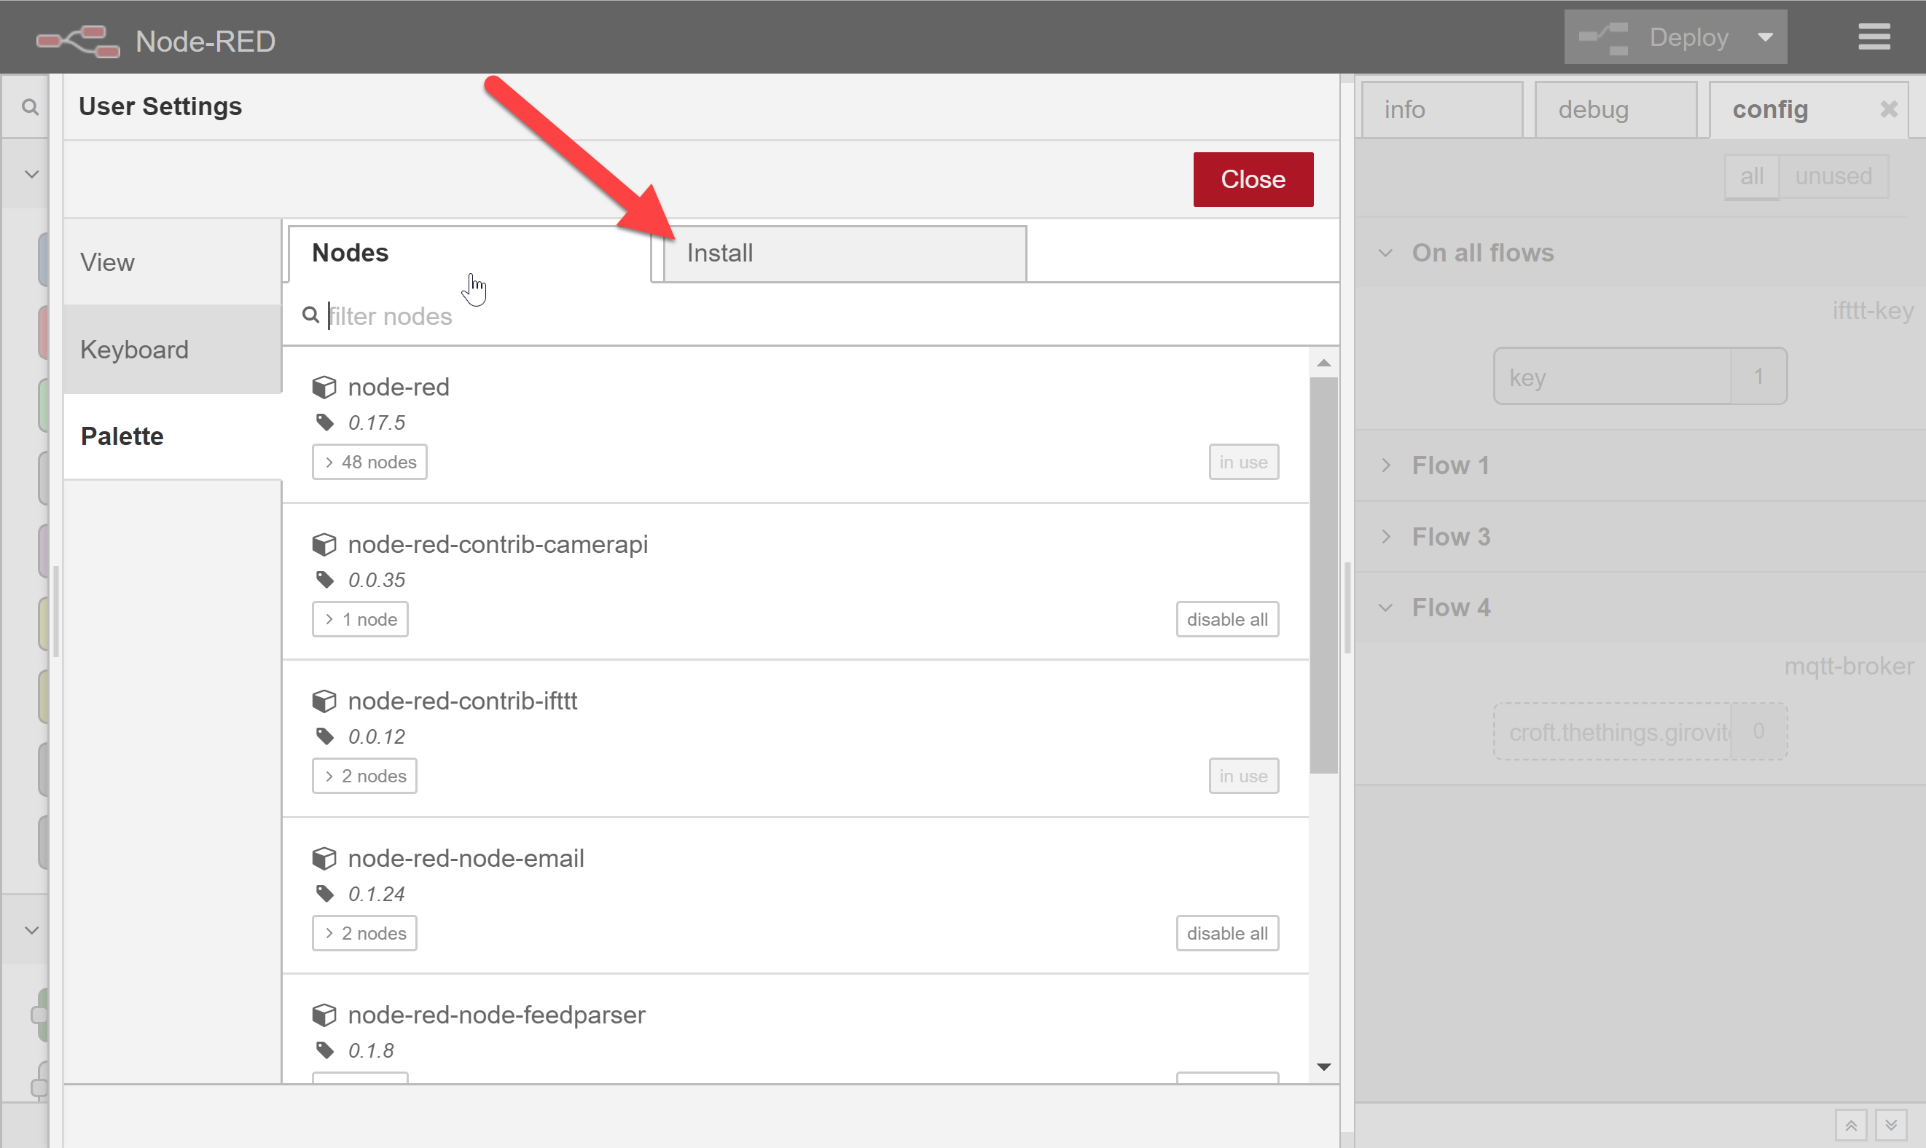

1. In the *Search Nodes* field, type **pushbullet**

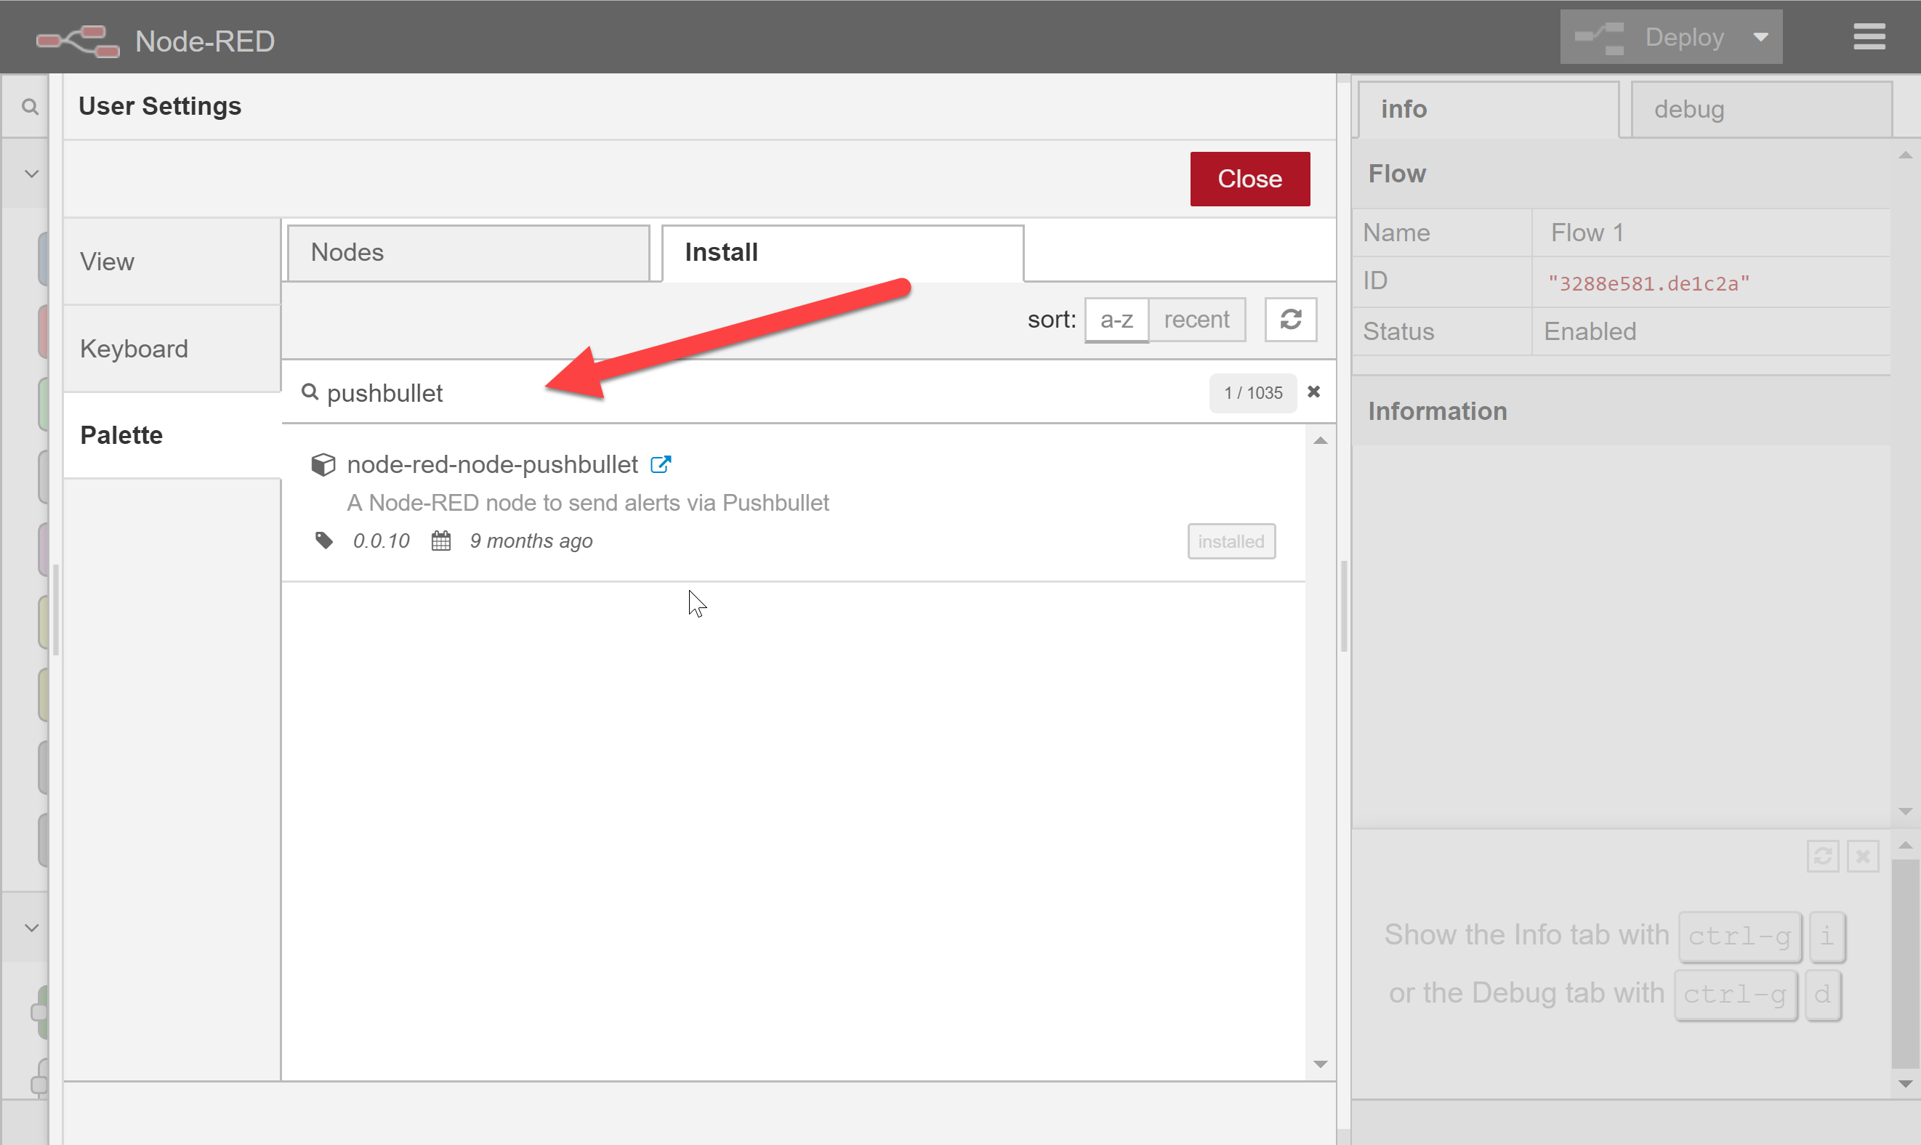

1. *node-red-node-pushbullet* should appear in the list of available palettes. Click the **Install** link to install the palette (note, in the screenshot below, the *Install* button is greyed-out and says “Installed” because the palette is already installed).

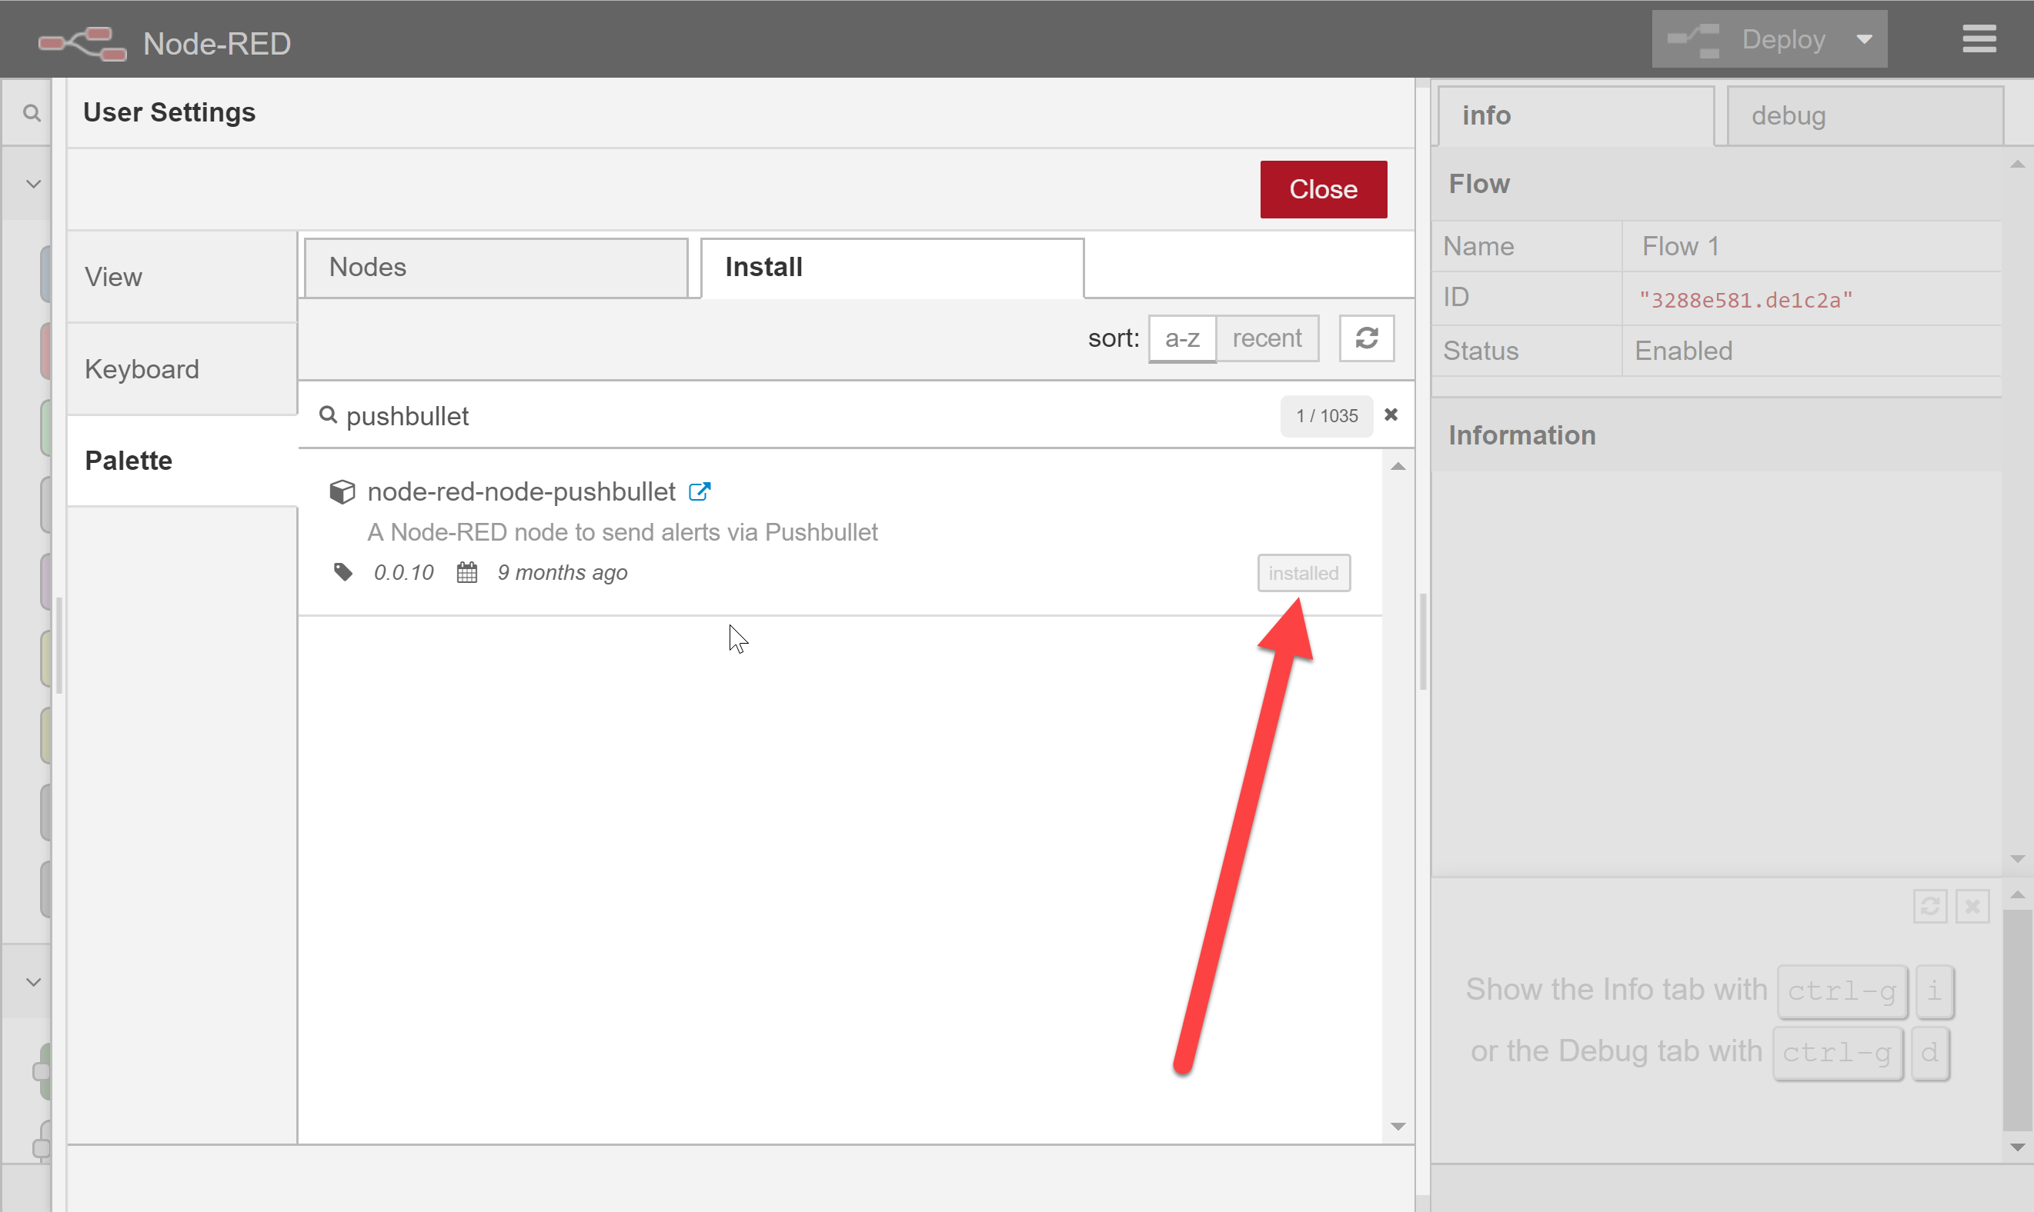

1. Once the new palette has been installed, click **Close**.

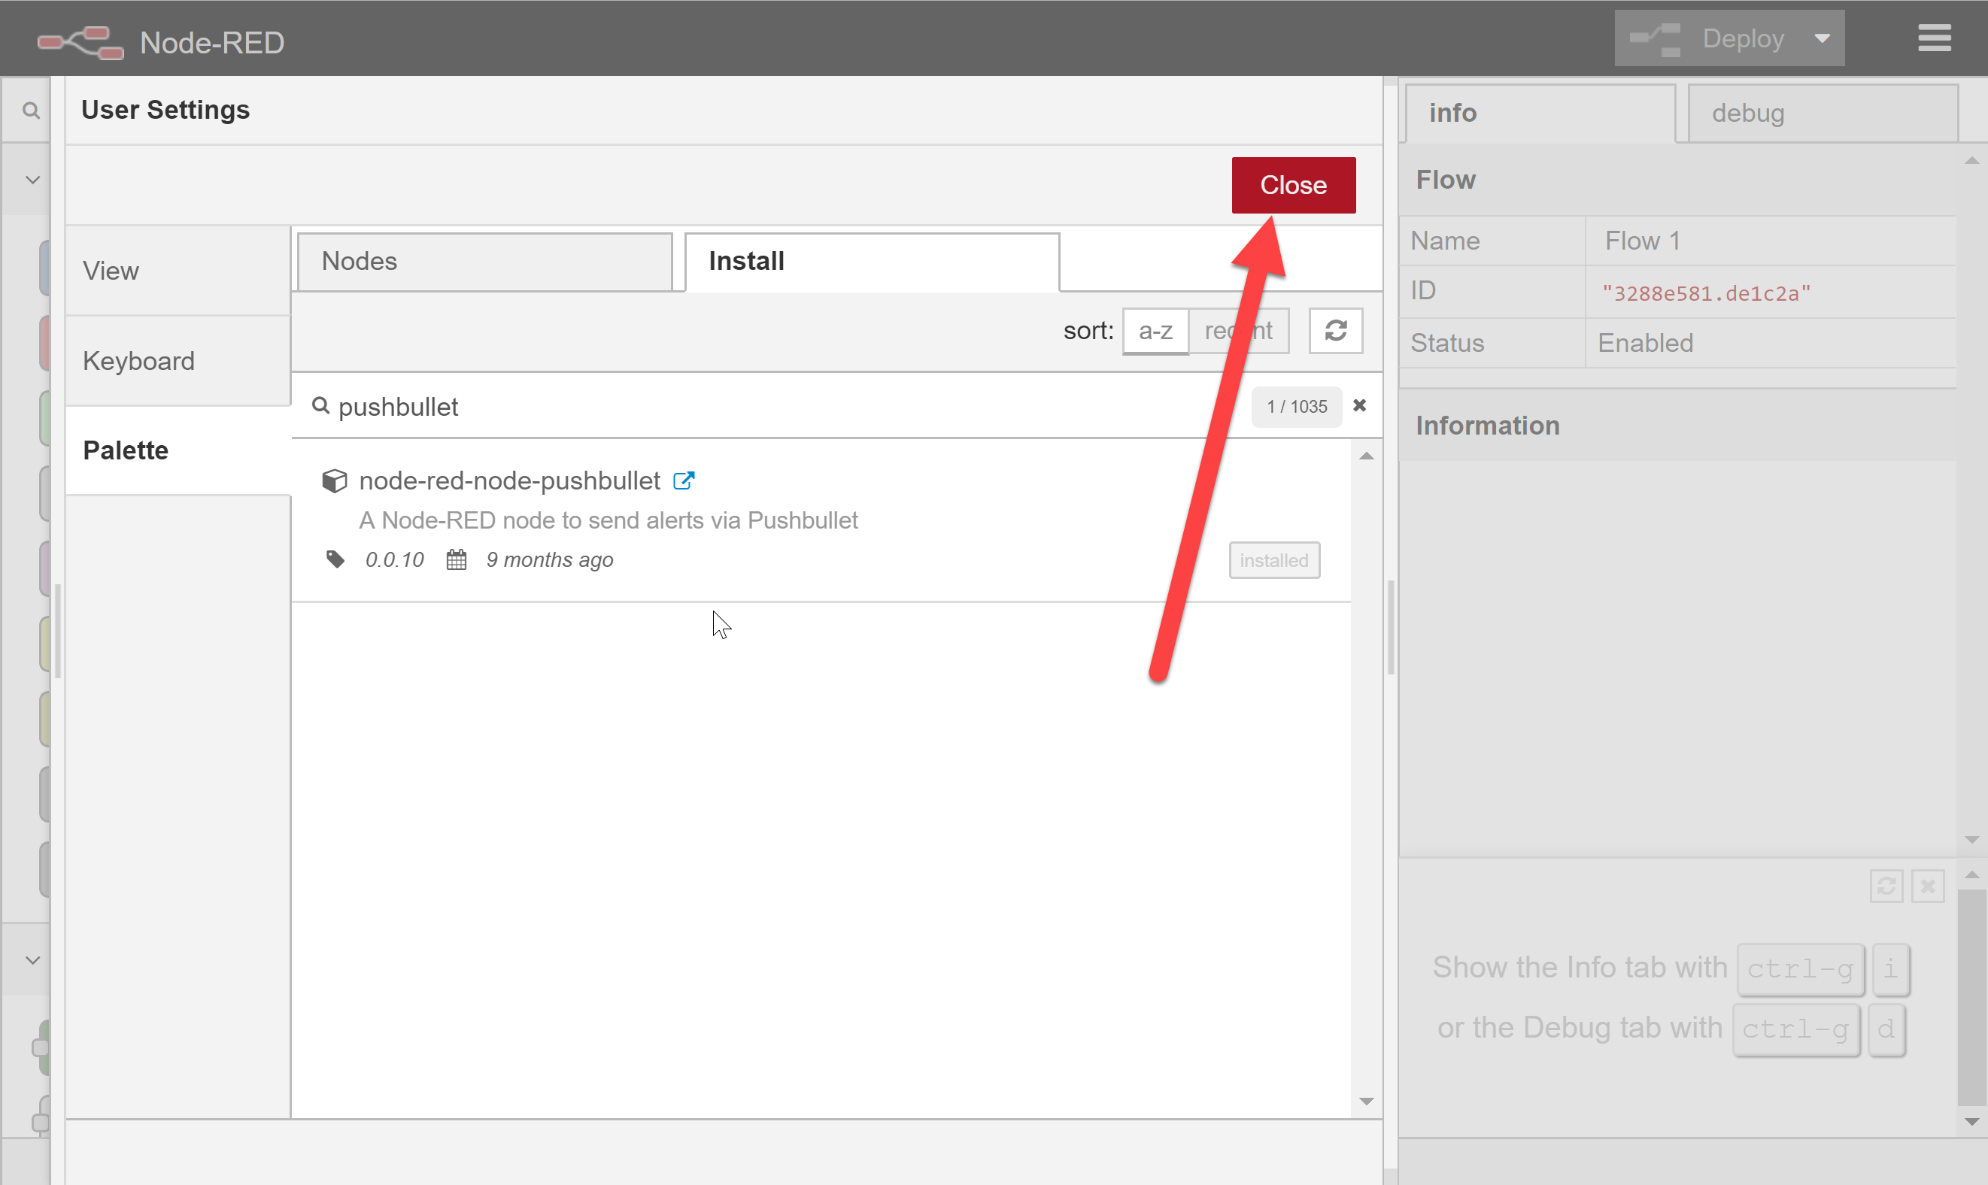

1. Two new *pushbullet* palettes should appear in the *mobile* group in Node Red
   1. Note: If the new palettes do not appear, shut down Node Red and close the Node Red tab or Window in your browser. Then, restart the Node Red server and browse to Node Red in a new tab or browser window.

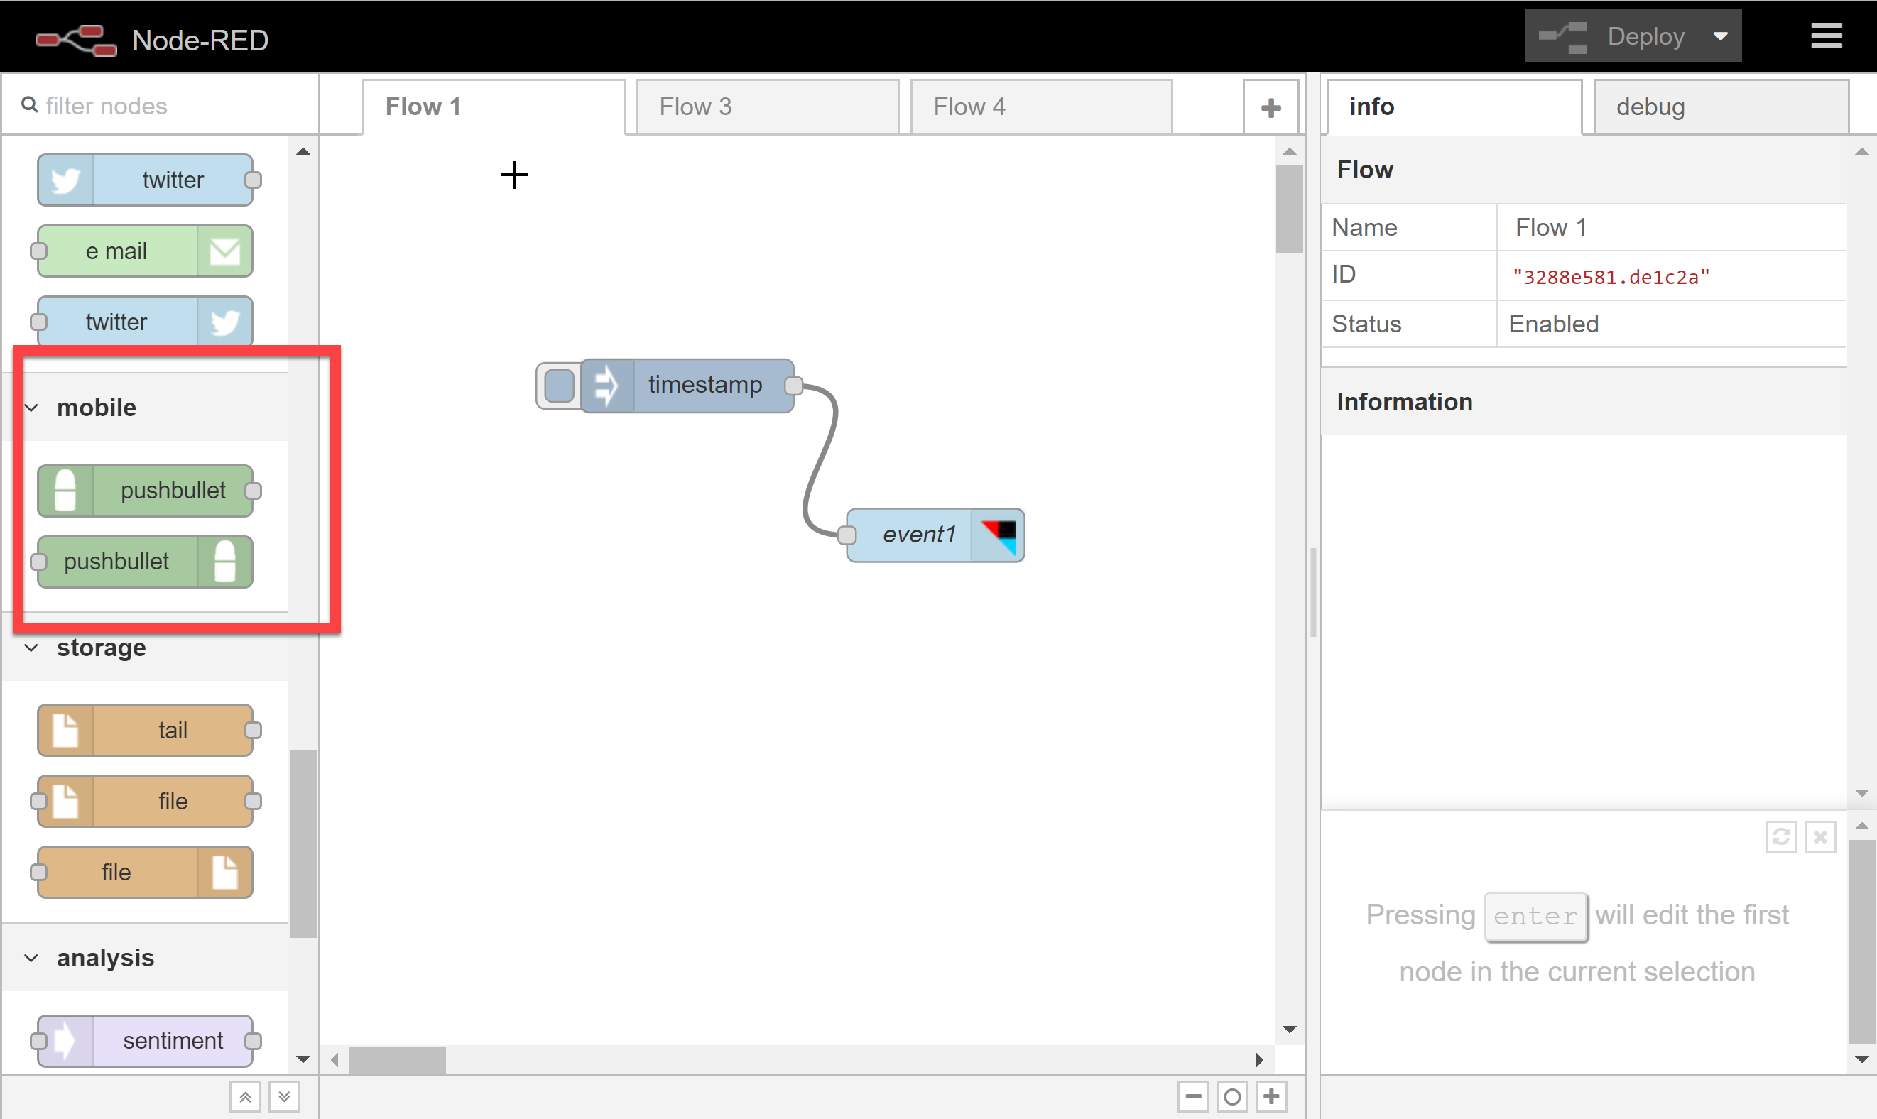

1. Drag a *pushbullet* push flow onto your canvas.

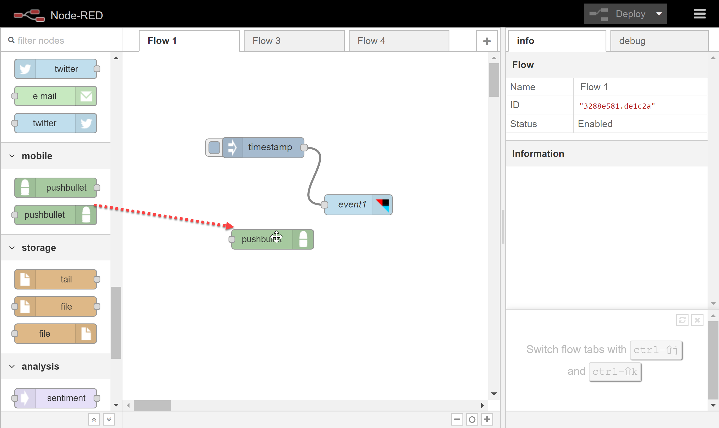

1. Double click on the *pushbullet* push flow to display the flow options pane.

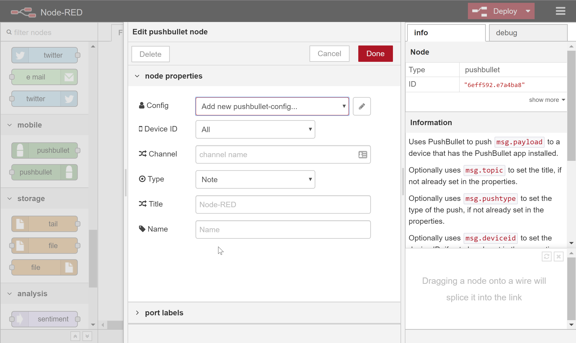

1. Let’s add a new pushbullet-config. Click on the **pencil** icon.

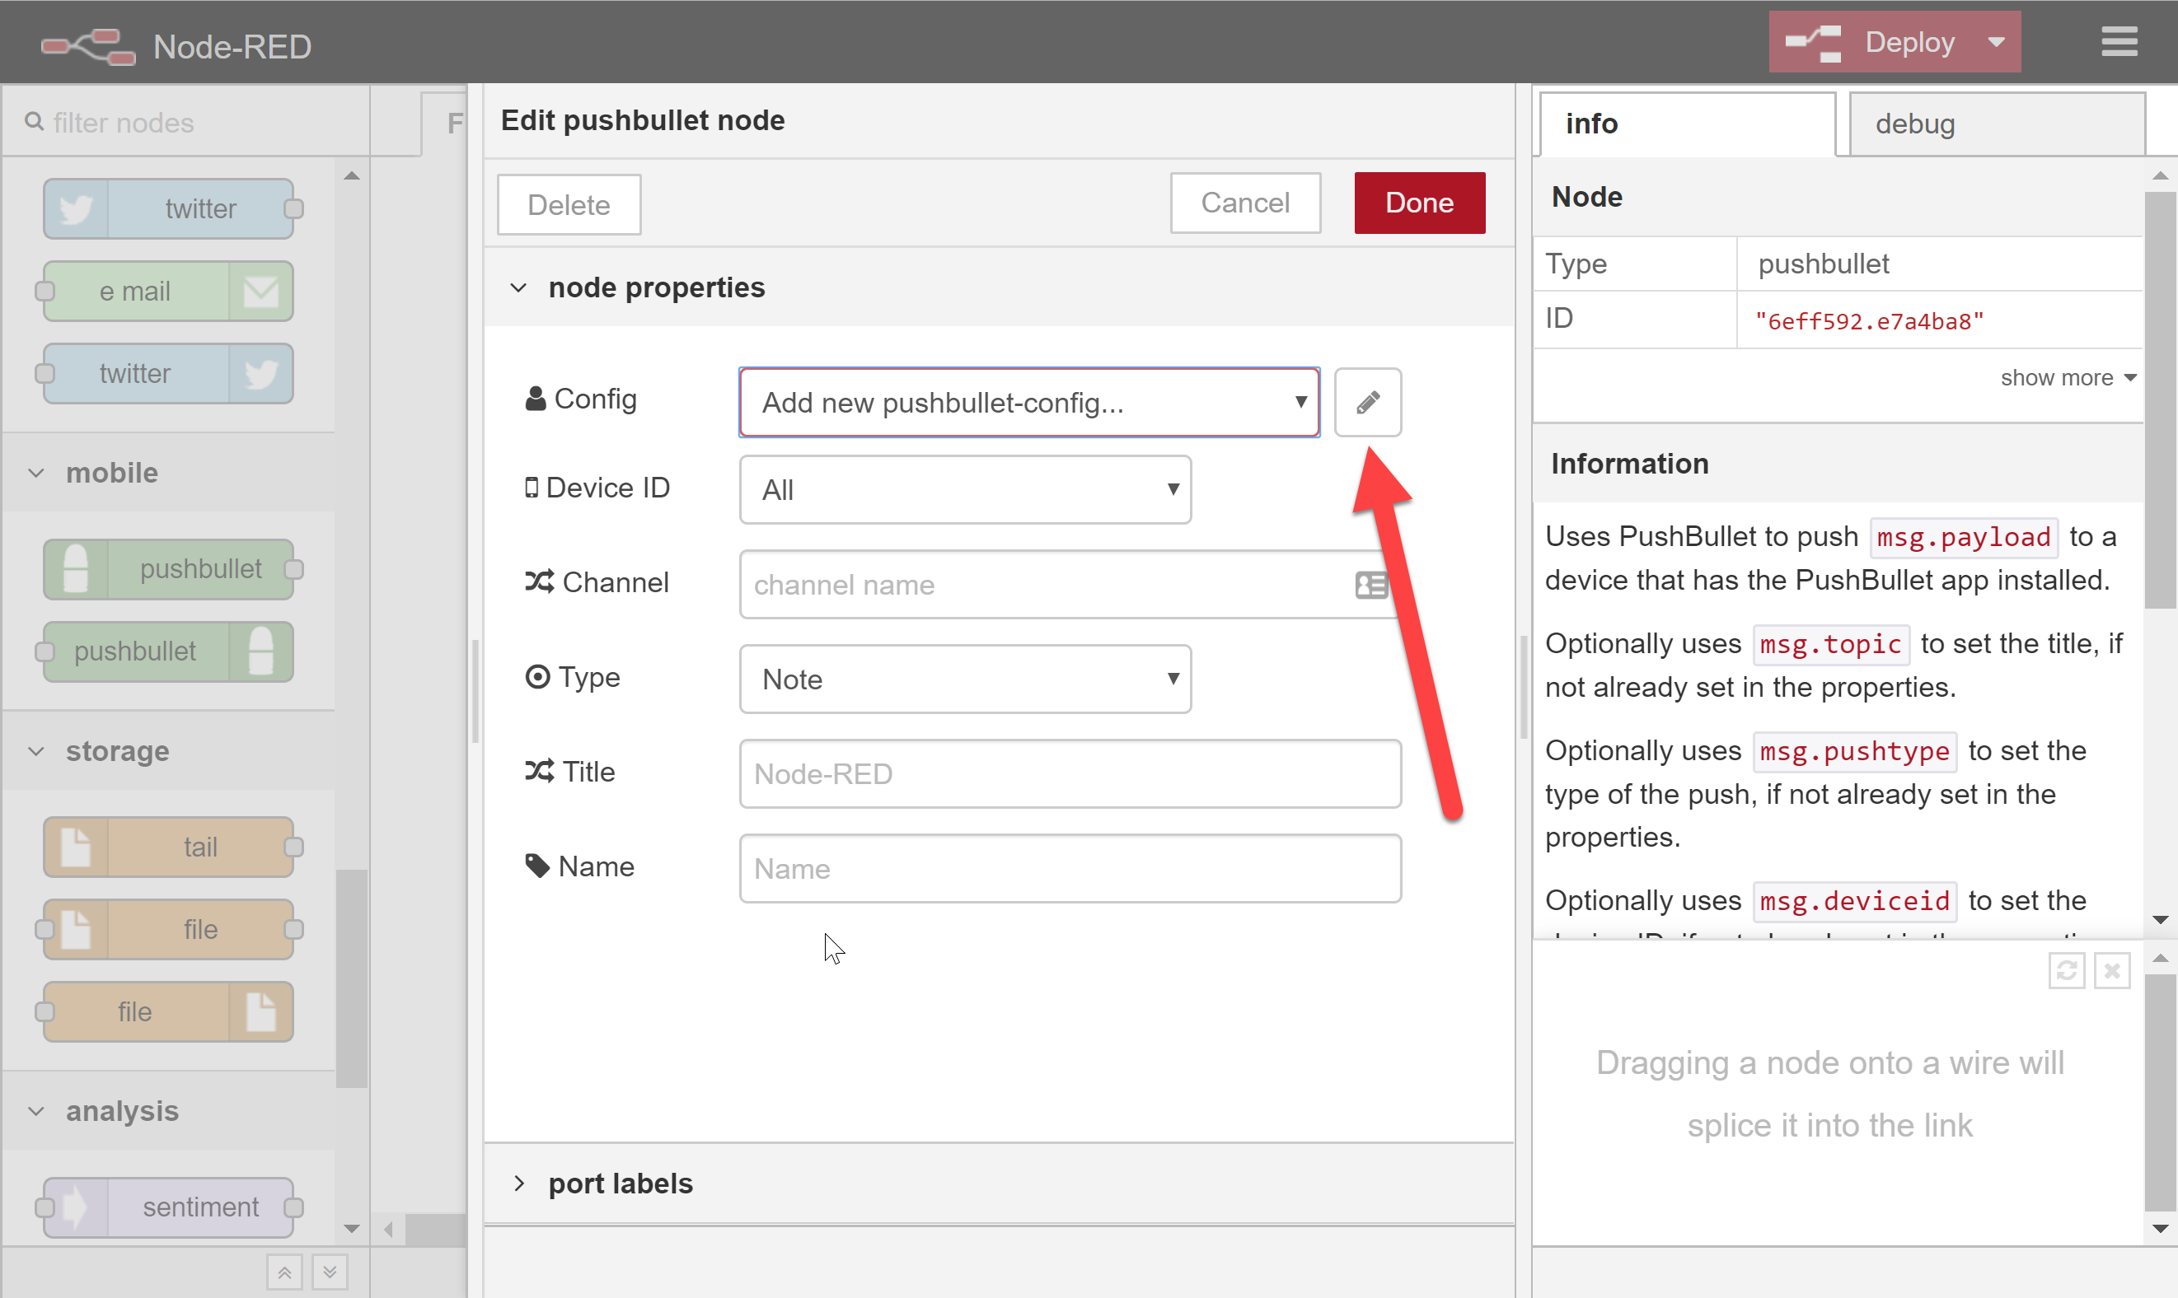

1. Return to the browser tab or window displaying your Pushbullet Access Token.
2. Highlight and copy the Access Token.

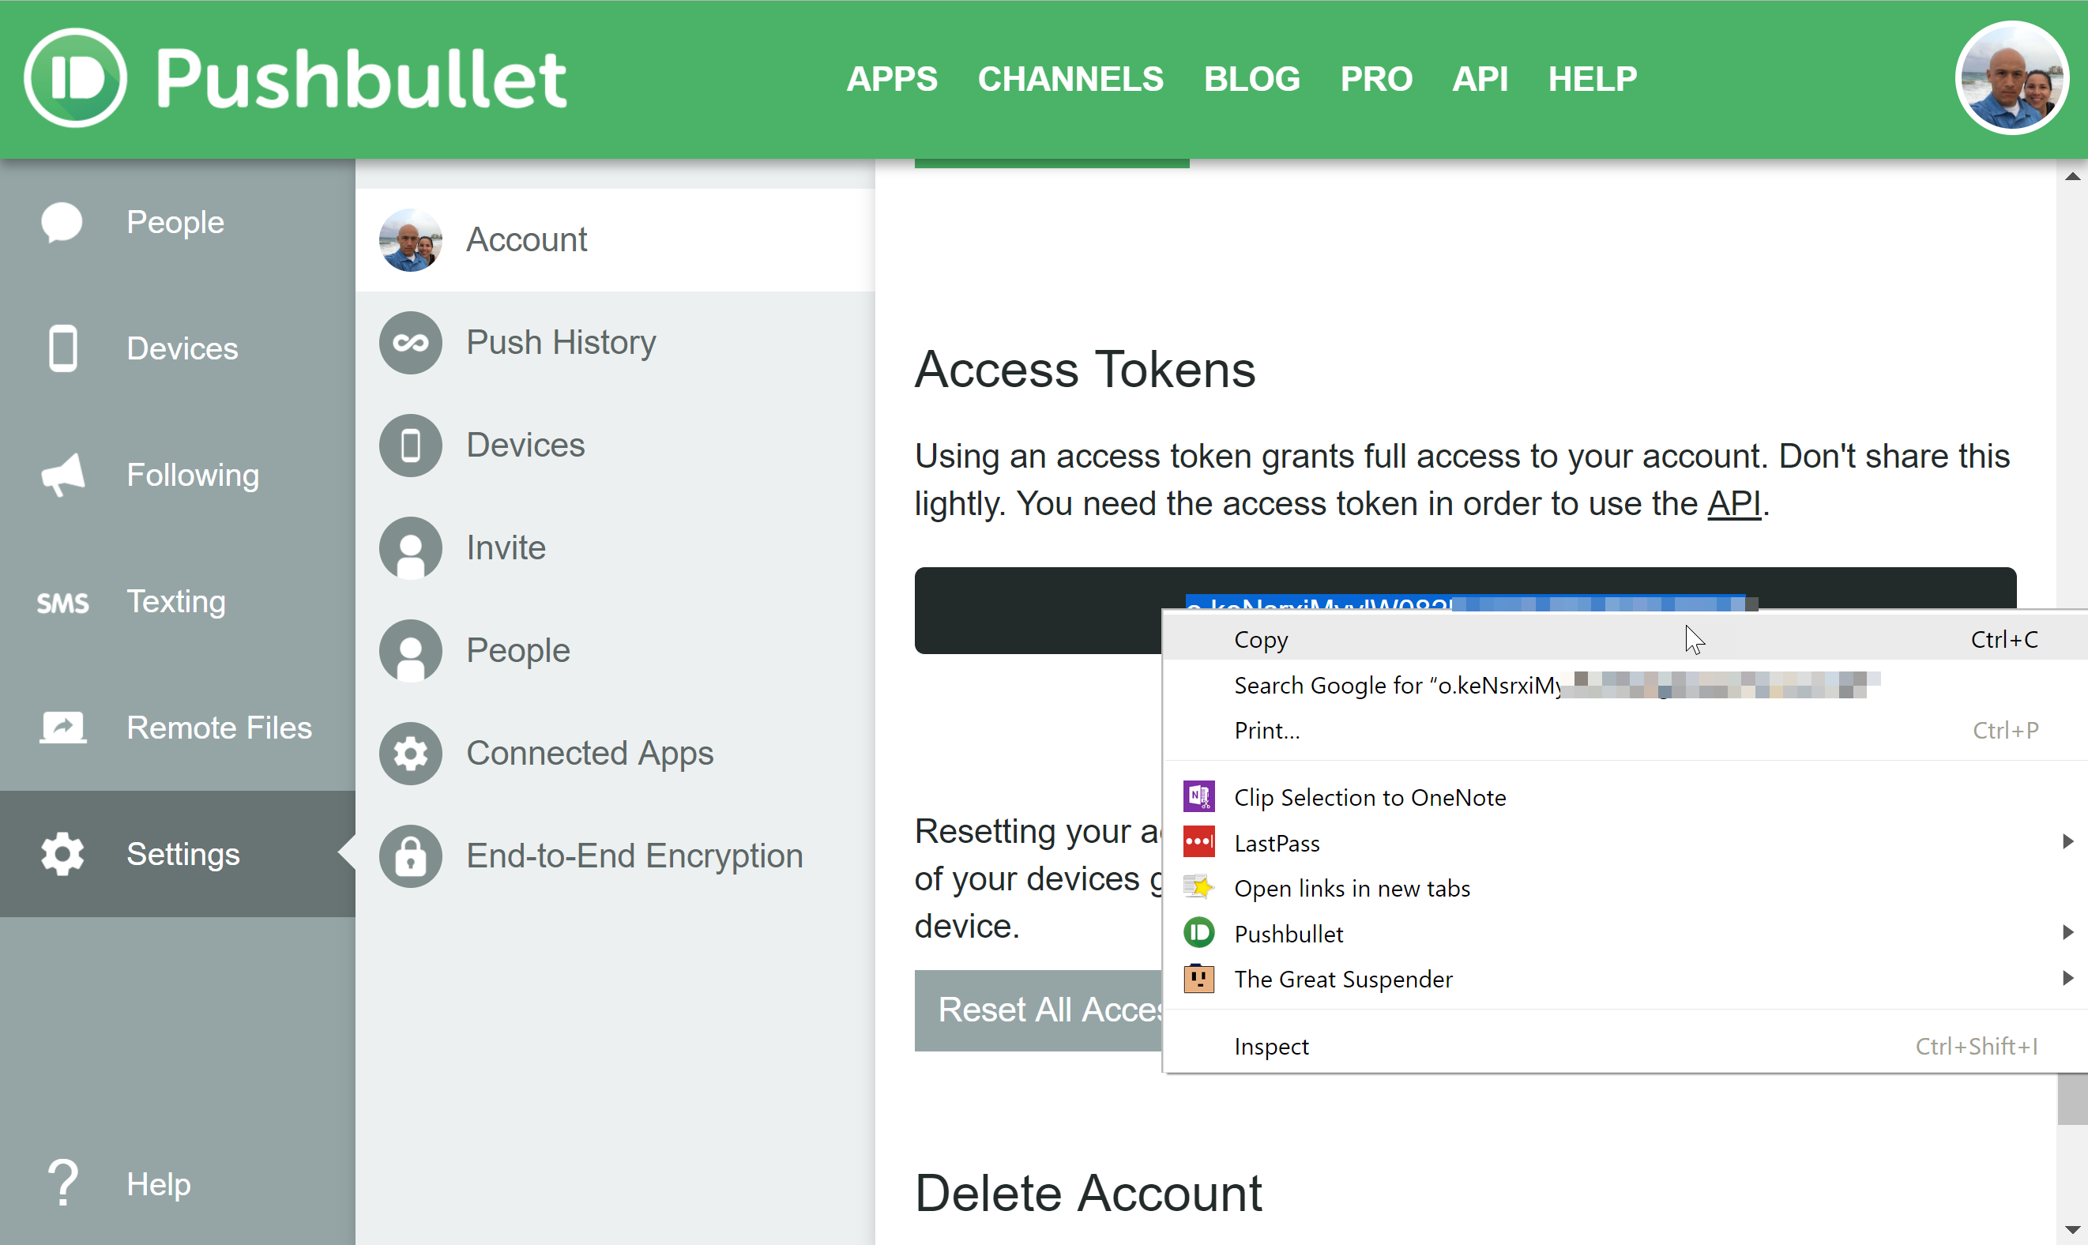

1. Switch back to the browser tab or window displaying Node Red.
2. Paste the Pushbullet Access Token into the *API-key* field in the configuration panel. Enter a name in the panel’s *Name* field and then click **Add**, which should return you to the *Edit pushbullet node* panel.

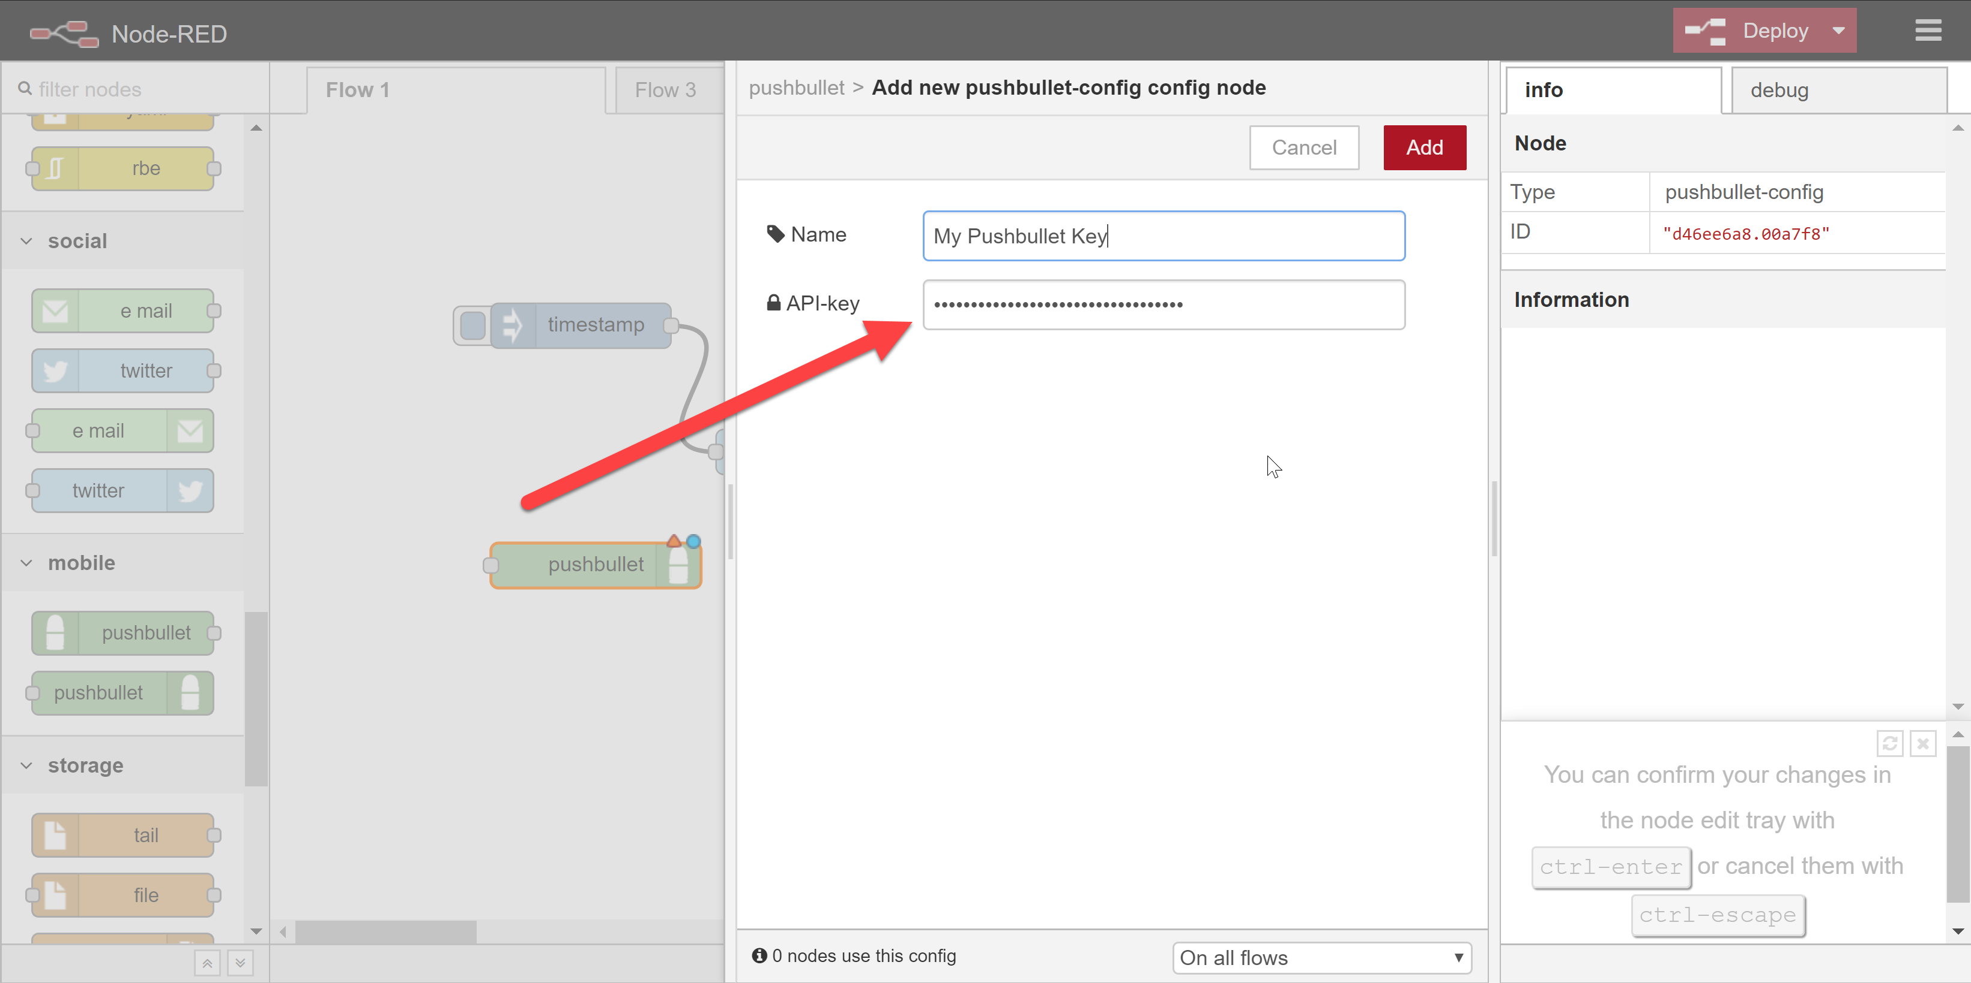

1. In the *Edit pushbullet node* panel:
   1. Select a device from the *Device ID* dropdown. **NOTE:** If no device’s appear, your API key may be incorrect!
   2. Select a message type from the *Type* dropdown. In the screenshot below, *File* has been selected. If you were pushing an image from a PI camera, you would want to use the *File* type to pass the image taken by the camera to your mobile device via Pushbullet.
   3. Optional: Enter a message title – this is the title of the message that will appear on your mobile device.
   4. Optional: Enter a name for the specific pushbullet node.
   5. When finished, click **Done**.

